Interior Intersection

Definition
# Source: AI Source: Provided by: [Data Path: Persons Table -> ID Column: 1, Name_En Column: Motasem Essam] -> From: [ChatGPT] on [7/25/2026]
Interior Intersection is a type of Segment Intersection that occurs when two line segments cross at a point that lies strictly inside both segments, rather than at either endpoint.
If segments $\overline{AB}$ and $\overline{CD}$ intersect at $P$, and $P$ is not an endpoint of either segment, then:
$$\boxed{\overline{AB}∩\overline{CD}=\{P\}}$$
with:
$$\boxed{P∈\operatorname{int}\left(\overline{AB}\right)}$$
and:
$$\boxed{P∈\operatorname{int}\left(\overline{CD}\right)}$$
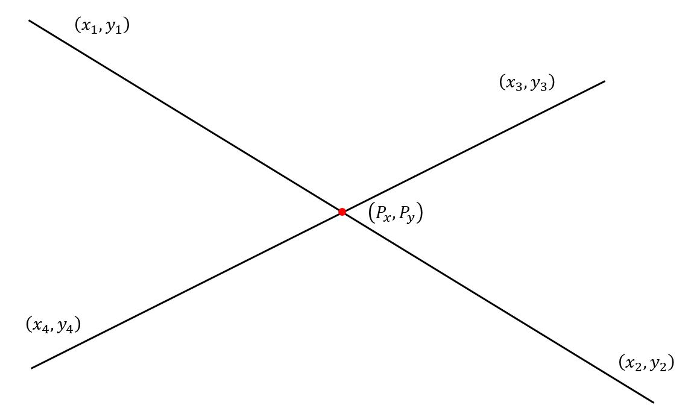
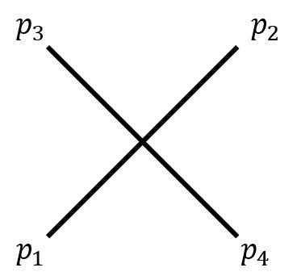
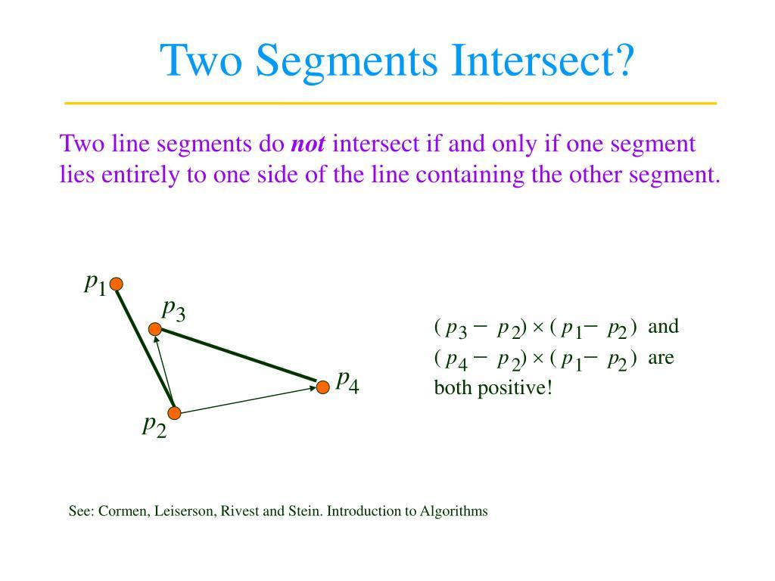

Purpose
# Source: AI Source: Provided by: [Data Path: Persons Table -> ID Column: 1, Name_En Column: Motasem Essam] -> From: [ChatGPT] on [7/25/2026]
Interior intersection is used to:
- Identify where two segments cross internally.
- Determine crossing points inside geometric figures.
- Analyze polygon diagonals.
- Study geometric relationships.
- Calculate intersection coordinates.
- Divide segments into smaller segments.
- Detect collisions between paths or objects.
- Support CAD, GIS, engineering, and computer graphics.

Fundamental Idea
# Source: AI Source: Provided by: [Data Path: Persons Table -> ID Column: 1, Name_En Column: Motasem Essam] -> From: [ChatGPT] on [7/25/2026]
The key idea is that the intersection point must be inside both segments.
For example:
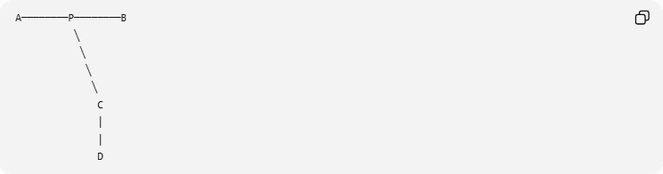
A────────P────────B
╲
╲
╲
╲
C
│
│
D
Here, $P$ is located between $A$ and $B$, and also between $C$ and $D$.
Therefore:
$$\boxed{\overline{AB}∩\overline{CD}=\{P\}}$$
and $P$ is an interior intersection point.

Mathematical Representation
# Source: AI Source: Provided by: [Data Path: Persons Table -> ID Column: 1, Name_En Column: Motasem Essam] -> From: [ChatGPT] on [7/25/2026]
For two segments:
$$\overline{AB}$$
and:
$$\overline{CD}$$
an interior intersection occurs when:
$$\boxed{\overline{AB}∩\overline{CD}=\{P\}}$$
and:
$$\boxed{P≠A, P≠B, P≠C, P≠D}$$
Therefore, $P$ is not an endpoint of either segment.

Interior Point of a Segment
# Source: AI Source: Provided by: [Data Path: Persons Table -> ID Column: 1, Name_En Column: Motasem Essam] -> From: [ChatGPT] on [7/25/2026]
A point $P$ is an interior point of segment $\overline{AB}$ when it lies strictly between $A$ and $B$.
In one-dimensional notation:
$$\boxed{A-P-B}$$
This means:
$$\boxed{AP+PB=AB}$$
with:
$$AP>0$$
and:
$$PB>0$$
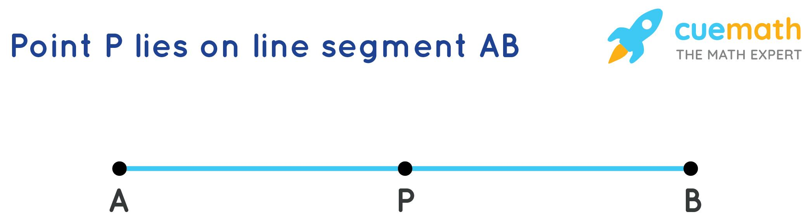
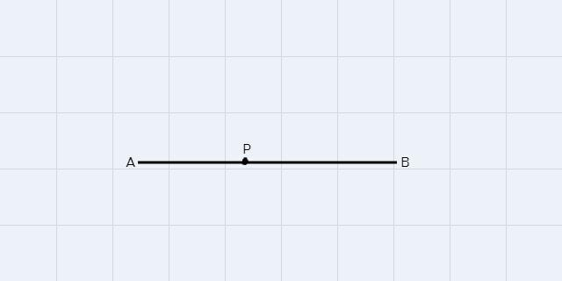
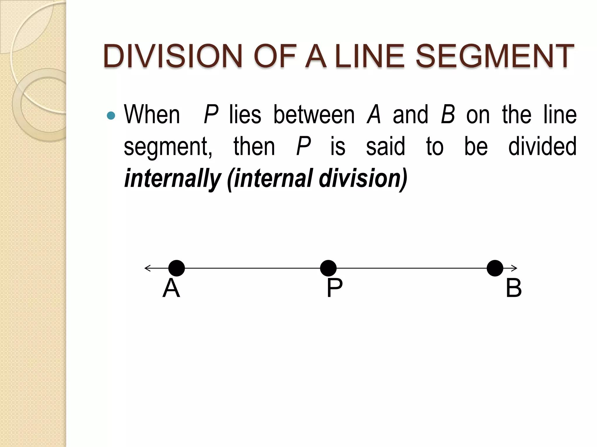

Interior Intersection of Two Segments
# Source: AI Source: Provided by: [Data Path: Persons Table -> ID Column: 1, Name_En Column: Motasem Essam] -> From: [ChatGPT] on [7/25/2026]
For two segments:
$$\overline{AB}$$
and:
$$\overline{CD}$$
an interior intersection has the form:
$$\boxed{A-P-B}$$
and simultaneously:
$$\boxed{C-P-D}$$
Thus, $P$ lies inside both segments.
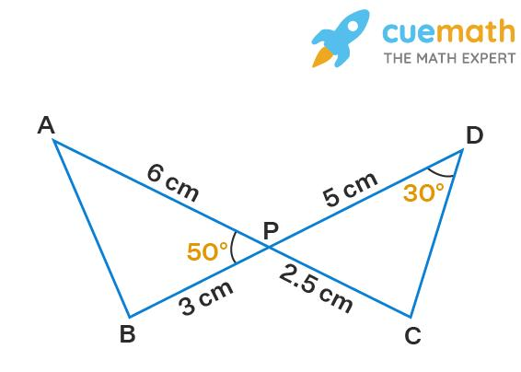
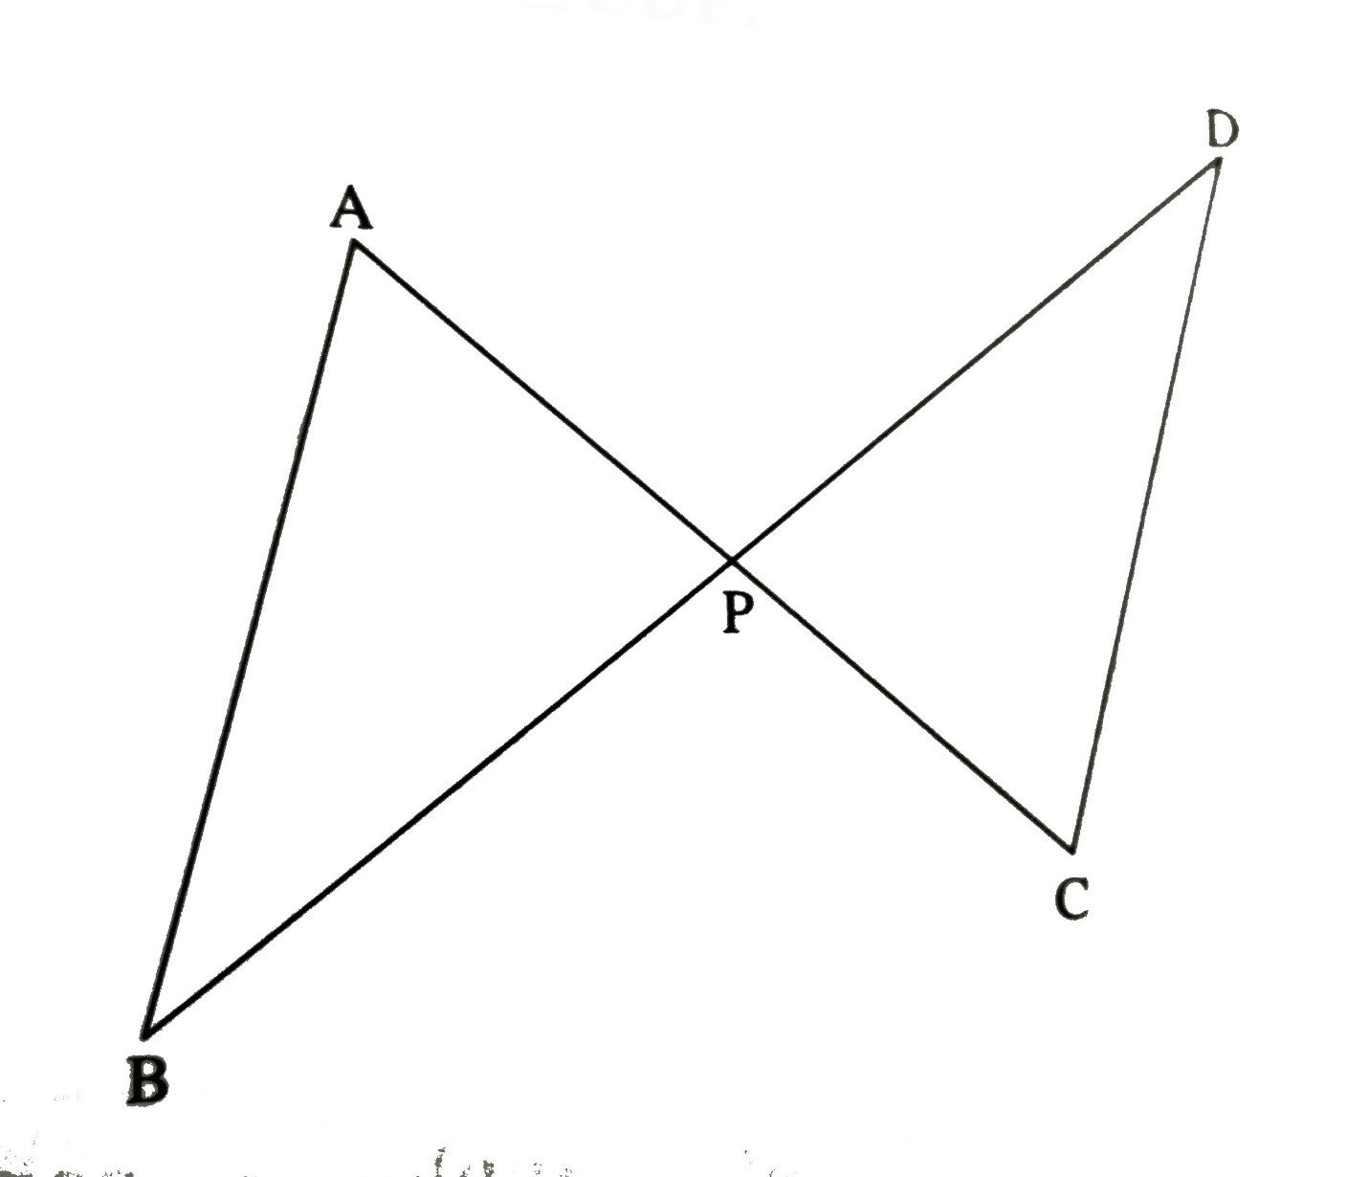

Example
# Source: AI Source: Provided by: [Data Path: Persons Table -> ID Column: 1, Name_En Column: Motasem Essam] -> From: [ChatGPT] on [7/25/2026]
Consider two segments:
$$A=\left(0,0\right) \\ B=\left(4,4\right)$$
and:
$$C=\left(0,4\right) \\ D=\left(4,0\right)$$
They intersect at:
$$\boxed{P=\left(2,2\right)}$$
Since $P$ lies between $A$ and $B$:
$$A-P-B$$
and between $C$ and $D$:
$$C-P-D$$
the intersection is an interior intersection.

Interior Intersection vs. Endpoint Intersection
# Source: AI Source: Provided by: [Data Path: Persons Table -> ID Column: 1, Name_En Column: Motasem Essam] -> From: [ChatGPT] on [7/25/2026]
These two types should be clearly distinguished.
Interior Intersection
The intersection point is inside both segments:
$$\boxed{A-P-B} \\ \boxed{C-P-D}$$
Endpoint Intersection
The intersection occurs at an endpoint:
$$\boxed{A=B?}$$
More correctly, if two segments share endpoint $B$:
$$\boxed{\overline{AB}∩\overline{BC}=\{B\}}$$
Here, $B$ is an endpoint, so it is not an interior intersection.
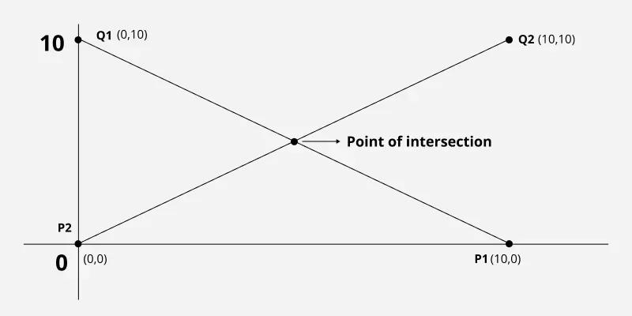
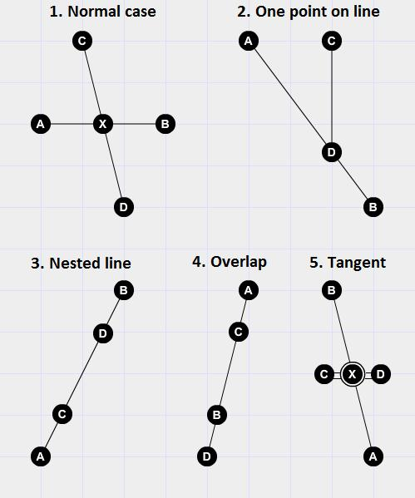

Interior Intersection vs. Multiple-Point Intersection
# Source: AI Source: Provided by: [Data Path: Persons Table -> ID Column: 1, Name_En Column: Motasem Essam] -> From: [ChatGPT] on [7/25/2026]
An interior intersection usually refers to a crossing at a point inside both segments.
For example:
$$\boxed{\overline{AB}∩\overline{CD}=\{P\}}$$
A multiple-point intersection means two objects share two or more distinct points.
Therefore:
- Interior intersection: describes where the intersection occurs.
- Multiple-point intersection: describes how many distinct intersection points exist.

Interior Intersection of Polygon Diagonals
# Source: AI Source: Provided by: [Data Path: Persons Table -> ID Column: 1, Name_En Column: Motasem Essam] -> From: [ChatGPT] on [7/25/2026]
One of the most common examples occurs when diagonals of a polygon cross inside the polygon.
For a quadrilateral $ABCD$:
$$\boxed{\overline{AC}∩\overline{BD}=\{P\}}$$
If $P$ lies inside both diagonals, then $P$ is an interior intersection.
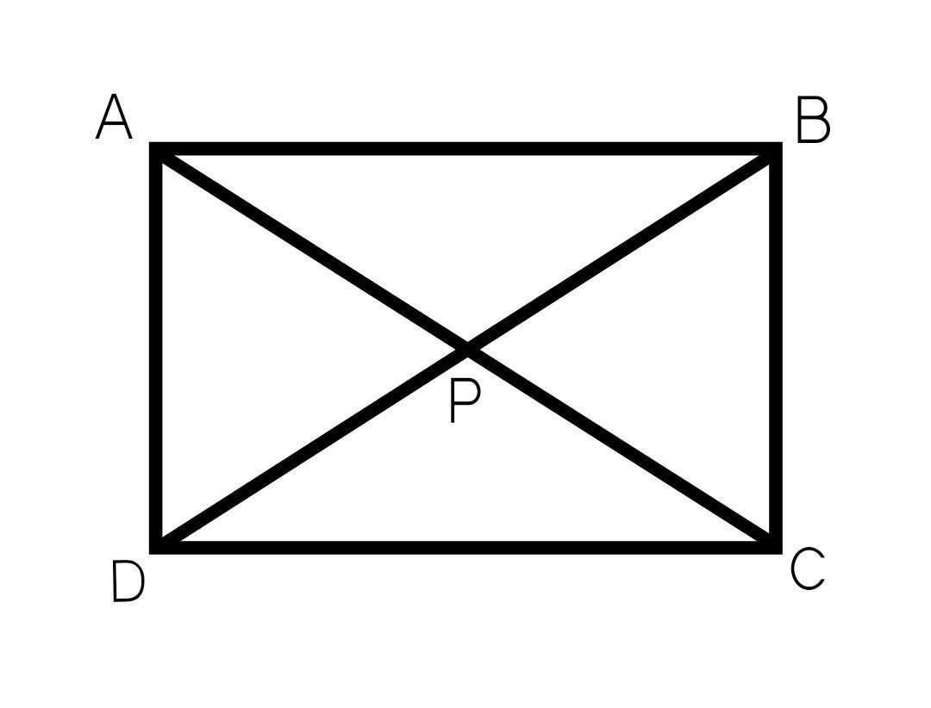
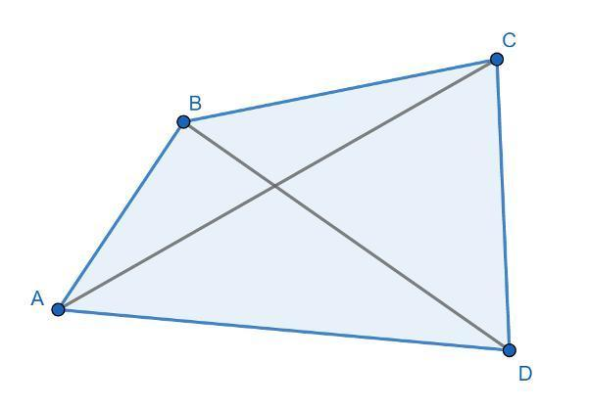
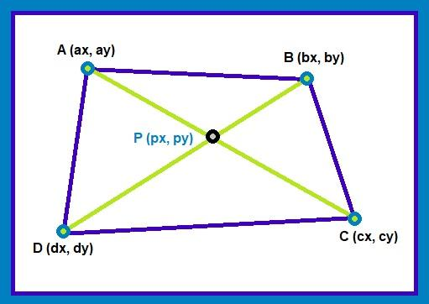
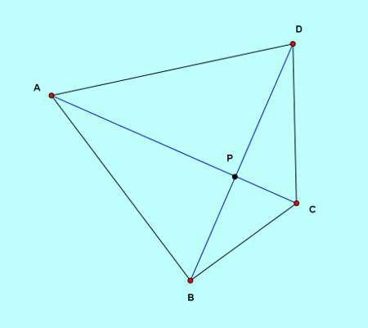
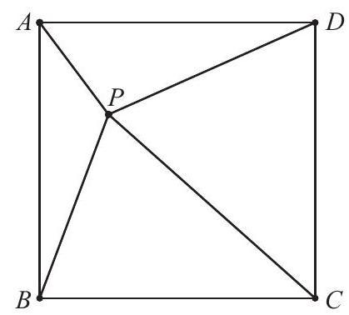

Interior Intersection in a Convex Polygon
# Source: AI Source: Provided by: [Data Path: Persons Table -> ID Column: 1, Name_En Column: Motasem Essam] -> From: [ChatGPT] on [7/25/2026]
In a convex polygon, diagonals can cross inside the polygon.
For example, several diagonals may produce interior intersection points.
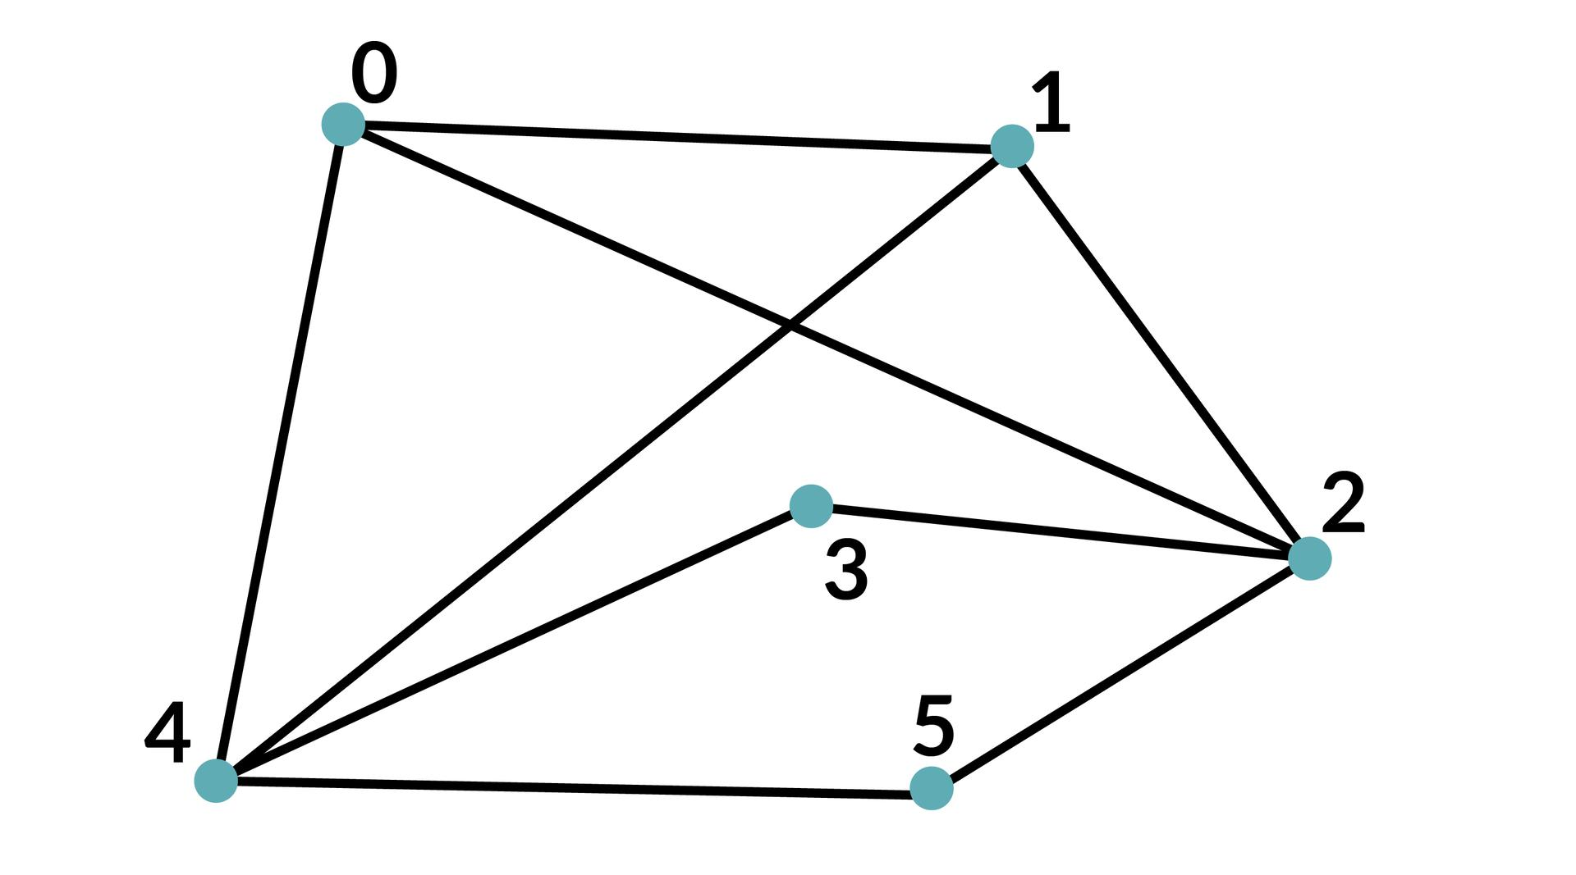
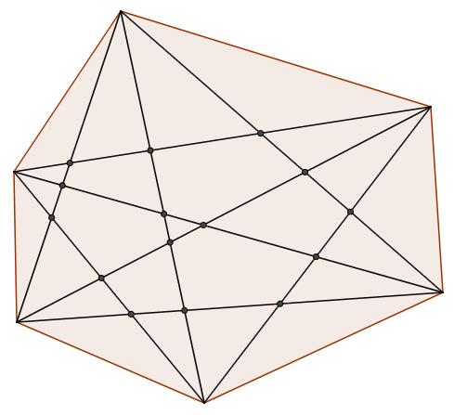
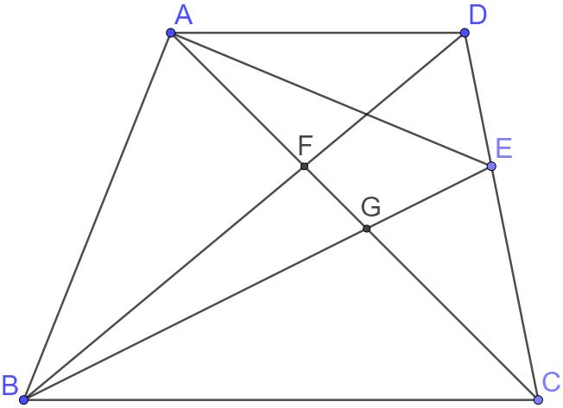
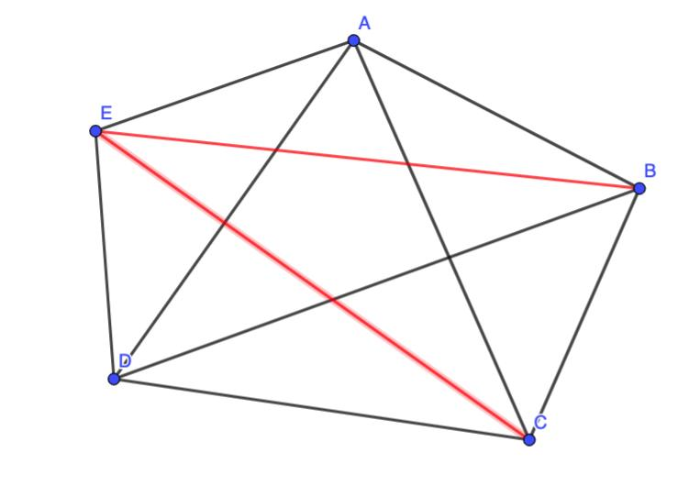
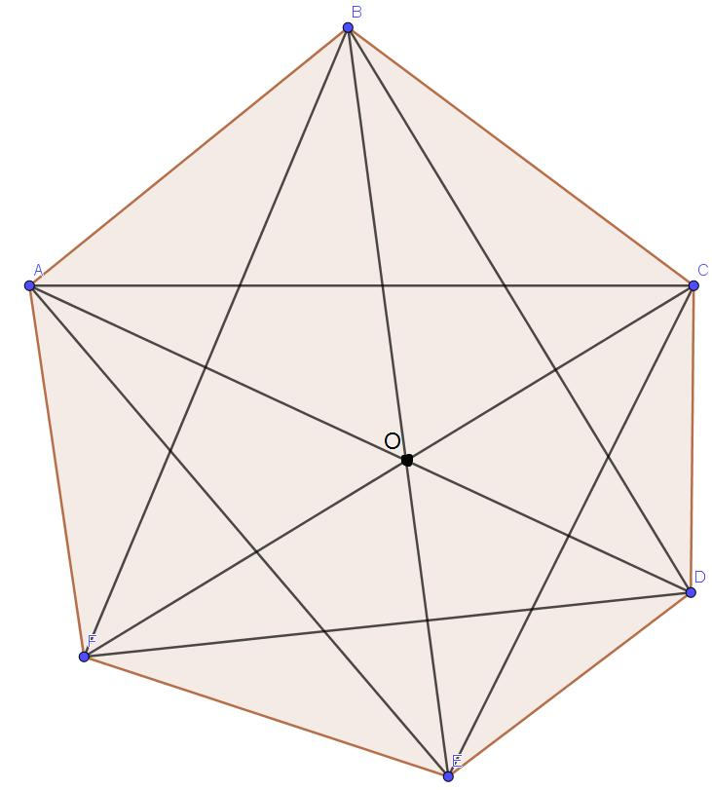
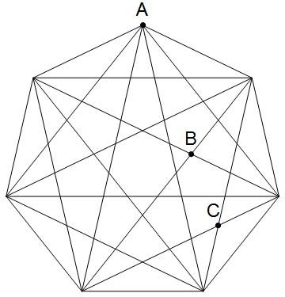
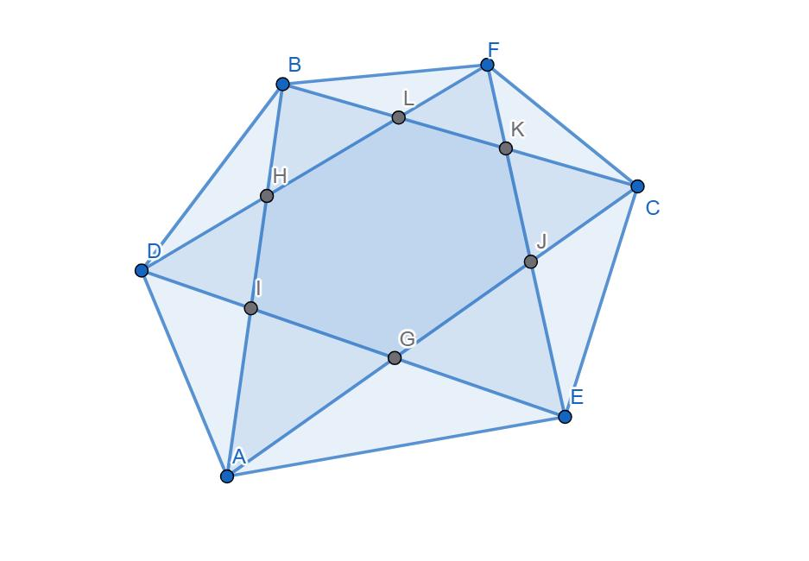
These points can divide the polygon into smaller regions.

Interior Intersection of Two Line Segments
# Source: AI Source: Provided by: [Data Path: Persons Table -> ID Column: 1, Name_En Column: Motasem Essam] -> From: [ChatGPT] on [7/25/2026]
Two non-collinear segments can cross at an interior point.
If:
$$P∈\overline{AB}$$
and:
$$P∈\overline{CD}$$
while:
$$P∉A,B,C,D$$
then:
$$\boxed{P\text{ is an interior intersection point}}$$

Interior Intersection and Angles
# Source: AI Source: Provided by: [Data Path: Persons Table -> ID Column: 1, Name_En Column: Motasem Essam] -> From: [ChatGPT] on [7/25/2026]
When two segments cross at an interior point, they form four angles around the intersection point.
For example:
$$\boxed{\overline{AB}∩\overline{CD}=\{P\}}$$
The four angles are:
$$∠APC, ∠CPB, ∠BPD, ∠DPA$$
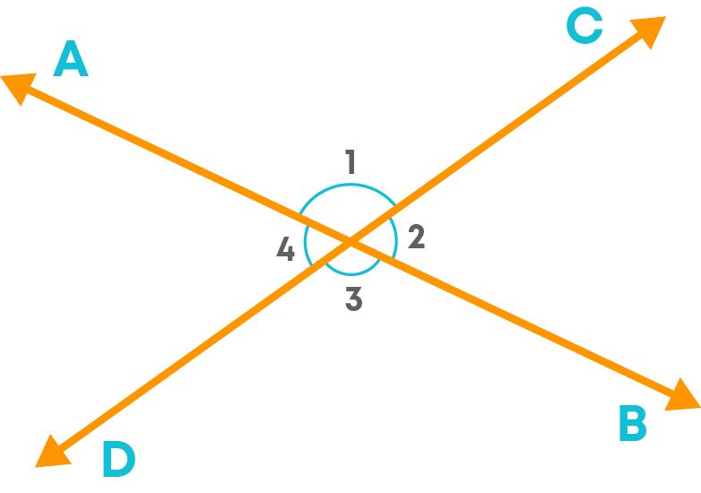
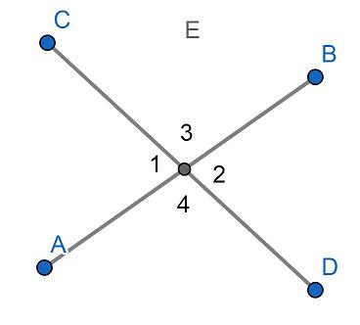
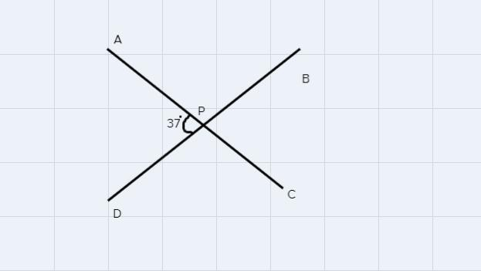
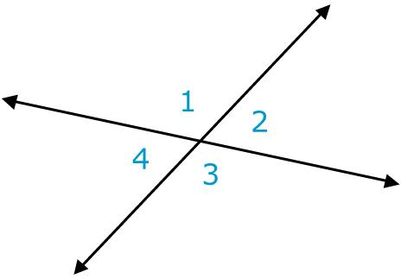
Opposite angles are vertical angles and are equal:
$$\boxed{∠APC=∠BPD}$$
and:
$$\boxed{∠CPB=∠DPA}$$

Perpendicular Interior Intersection
# Source: AI Source: Provided by: [Data Path: Persons Table -> ID Column: 1, Name_En Column: Motasem Essam] -> From: [ChatGPT] on [7/25/2026]
A special case occurs when two segments intersect at ${90}^{∘}$.
Then:
$$\boxed{\overline{AB}⊥\overline{CD}}$$
and:
$$\boxed{∠APC={90}^{∘}}$$
All four angles around $P$ are right angles.
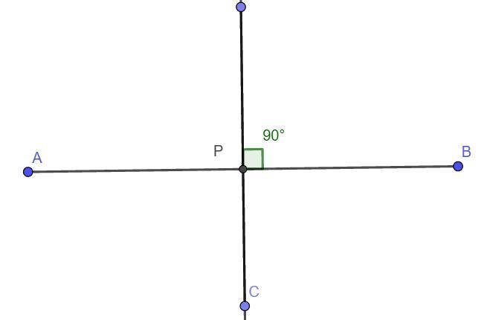
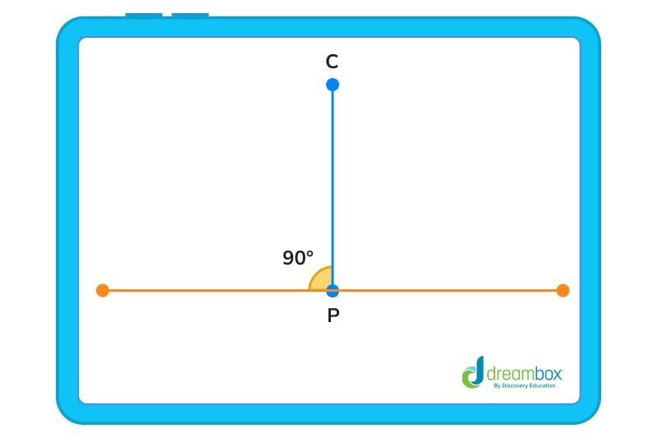
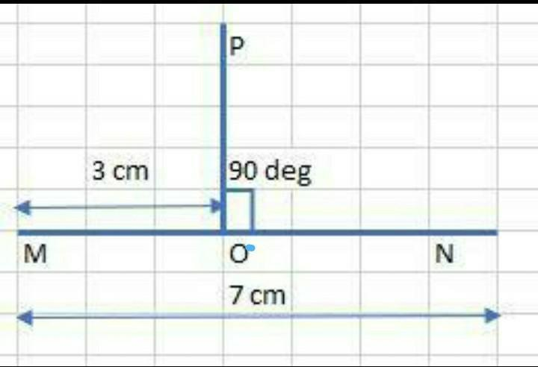

Interior Intersection in Coordinate Geometry
# Source: AI Source: Provided by: [Data Path: Persons Table -> ID Column: 1, Name_En Column: Motasem Essam] -> From: [ChatGPT] on [7/25/2026]
In coordinate geometry, segments are often represented parametrically.
For segment $AB$:
$$\boxed{P=A+t\left(B-A\right)}$$
where:
$$\boxed{0<t<1}$$
The condition:
$$0<t<1$$
means that $P$ lies strictly inside the segment.
Similarly, for segment $CD$:
$$\boxed{P=C+u\left(D-C\right)}$$
where:
$$\boxed{0<u<1}$$
Therefore, an interior intersection satisfies:
$$\boxed{P=A+t\left(B-A\right)=C+u\left(D-C\right)}$$
with:
$$\boxed{0<t<1, 0<u<1}$$

Why the Parameter Must Be Between 0 and 1
# Source: AI Source: Provided by: [Data Path: Persons Table -> ID Column: 1, Name_En Column: Motasem Essam] -> From: [ChatGPT] on [7/25/2026]
For:
$$P=A+t\left(B-A\right)$$
different values of $t$ represent different locations.
$$t=0 \\ P=A$$
This is an endpoint.
$$0<t<1$$
$$P\text{ is inside }\overline{AB}$$
$$t=1$$
$$P=B$$
This is an endpoint.
Therefore:
$$\boxed{0<t<1}$$
is the mathematical condition for an interior point.

Example with Parameters
# Source: AI Source: Provided by: [Data Path: Persons Table -> ID Column: 1, Name_En Column: Motasem Essam] -> From: [ChatGPT] on [7/25/2026]
Suppose:
$$A=\left(0,0\right)$$
and:
$$B=\left(10,10\right)$$
If:
$$t=0.5$$
then:
$$P=A+0.5\left(B-A\right) \\ P=\left(0,0\right)+0.5\left(10,10\right) \\ \boxed{P=\left(5,5\right)}$$
Since:
$$0<0.5<1$$
$P$ is inside $\overline{AB}$.

Interior Intersection and Segment Division
# Source: AI Source: Provided by: [Data Path: Persons Table -> ID Column: 1, Name_En Column: Motasem Essam] -> From: [ChatGPT] on [7/25/2026]
An interior intersection divides each segment into two smaller segments.
If:
$$\overline{AB}∩\overline{CD}=\{P\}$$
then:
$$\overline{AB}$$
is divided into:
$$\boxed{\overline{AP}\text{ and }\overline{PB}}$$
while:
$$\overline{CD}$$
is divided into:
$$\boxed{\overline{CP}\text{ and }\overline{PD}}$$
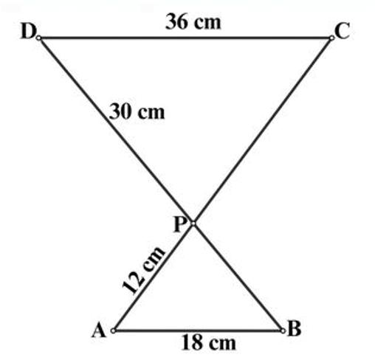
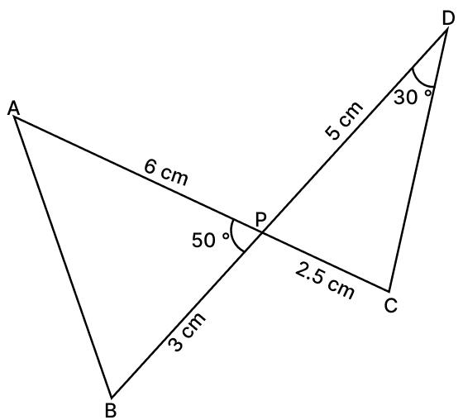

Interior Intersection in Triangles
# Source: AI Source: Provided by: [Data Path: Persons Table -> ID Column: 1, Name_En Column: Motasem Essam] -> From: [ChatGPT] on [7/25/2026]
The sides of a triangle normally meet at their endpoints, but segments drawn inside the triangle can create interior intersections.
For example, two cevians may cross at an interior point.
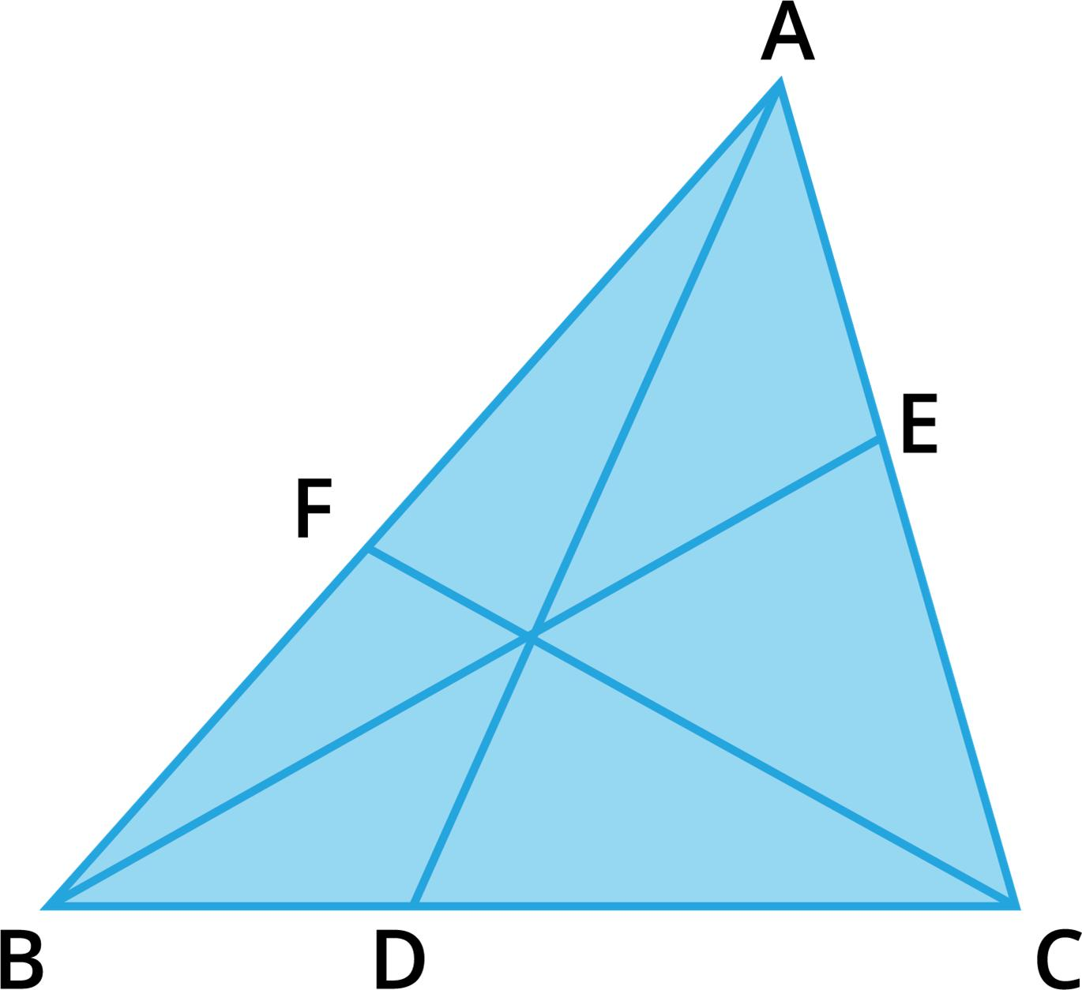
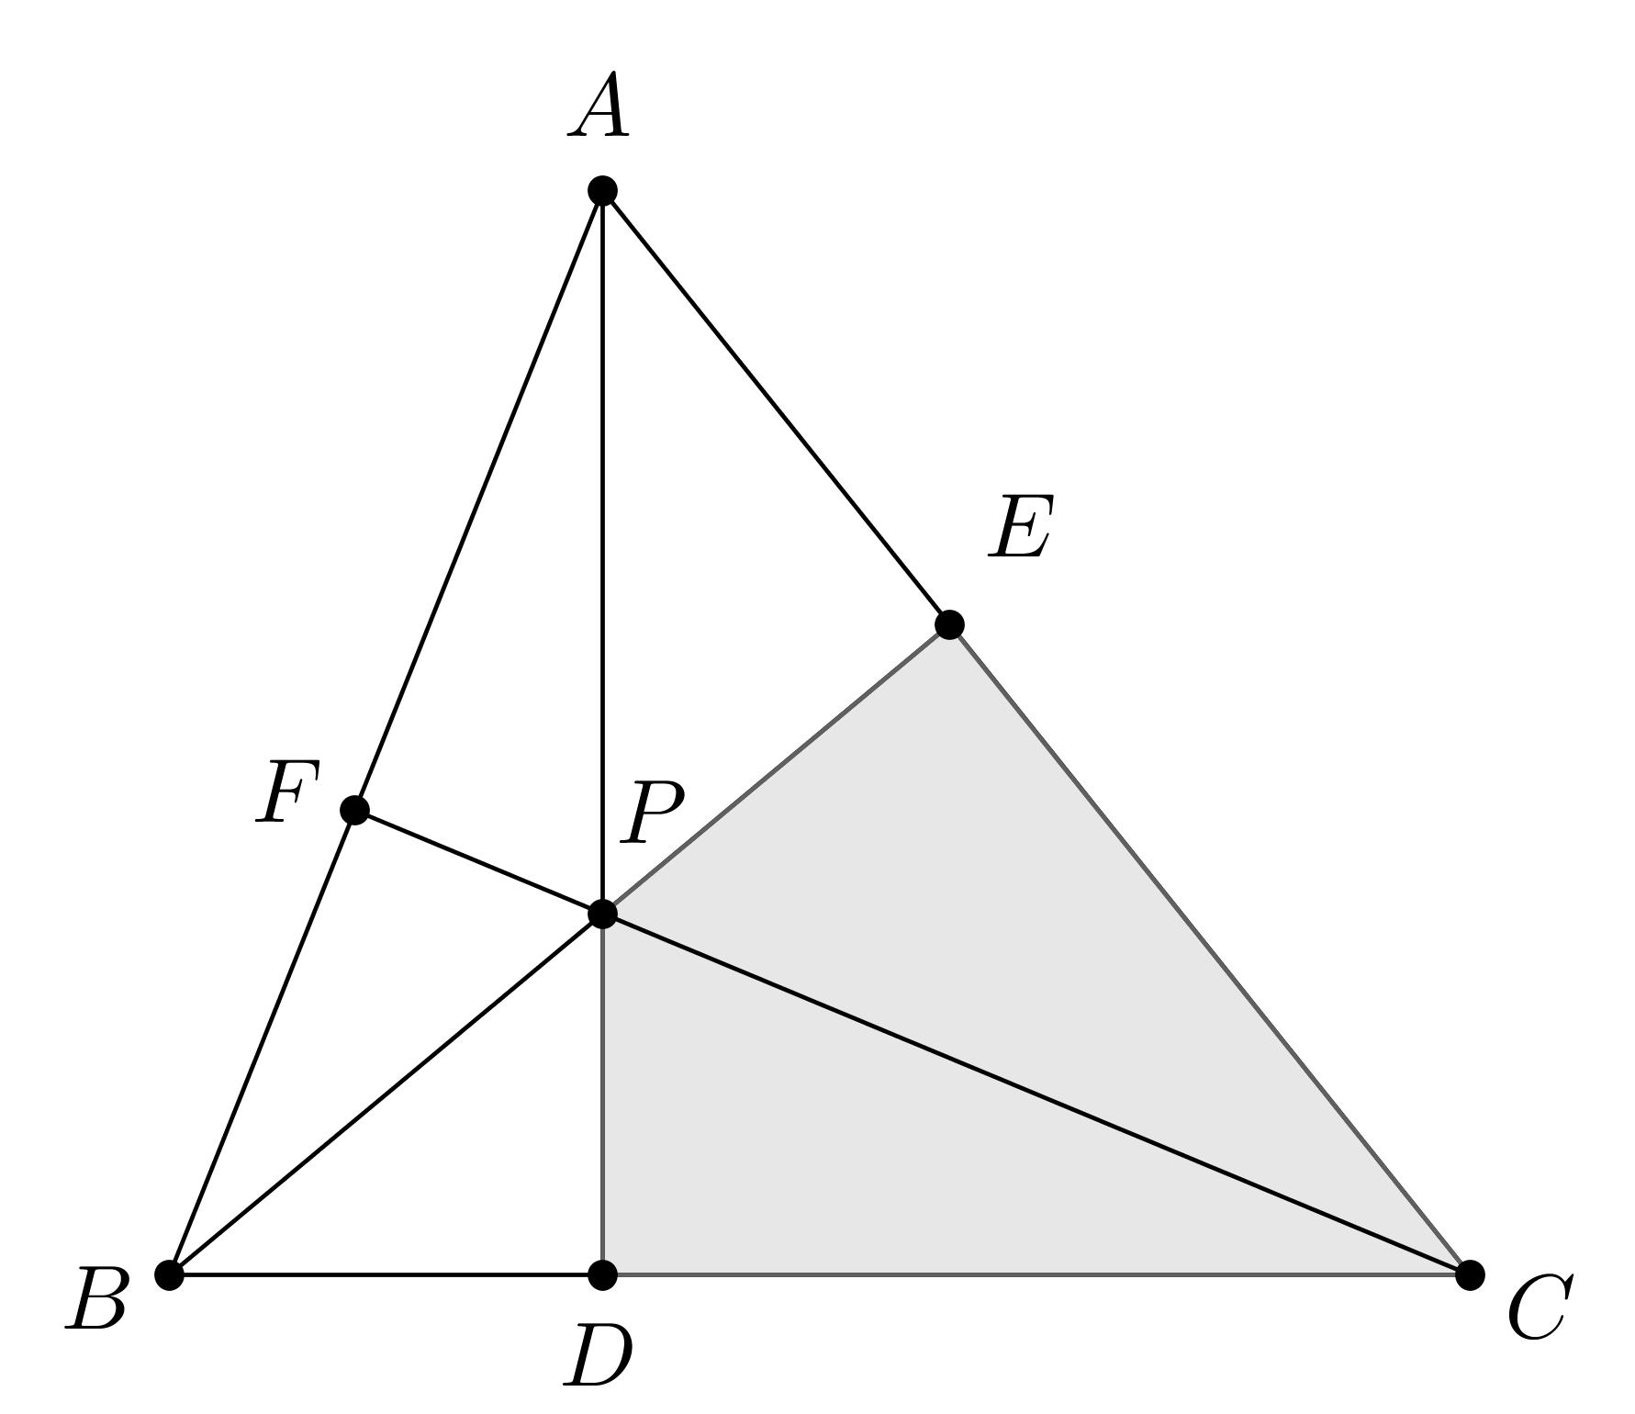
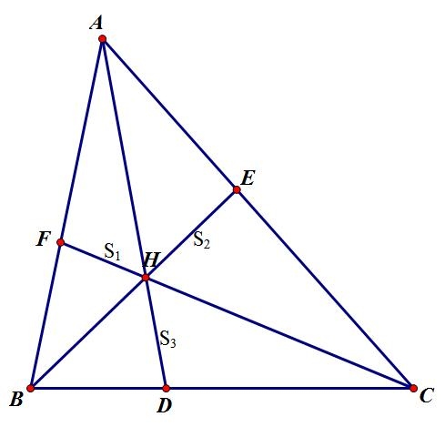
A famous example is the median intersection, where the three medians of a triangle meet at the centroid.

Interior Intersection in a Grid
# Source: AI Source: Provided by: [Data Path: Persons Table -> ID Column: 1, Name_En Column: Motasem Essam] -> From: [ChatGPT] on [7/25/2026]
A geometric grid contains many segments.
Segments can intersect at interior points depending on how the grid is constructed.
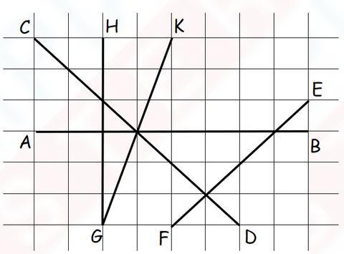
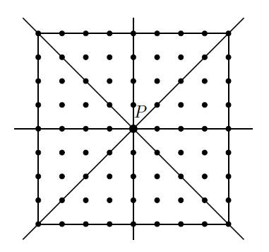
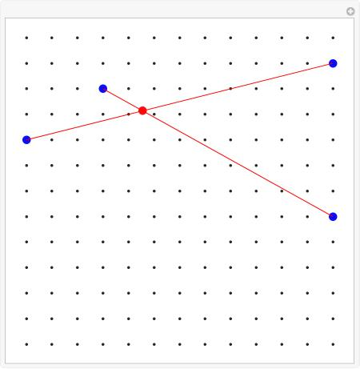
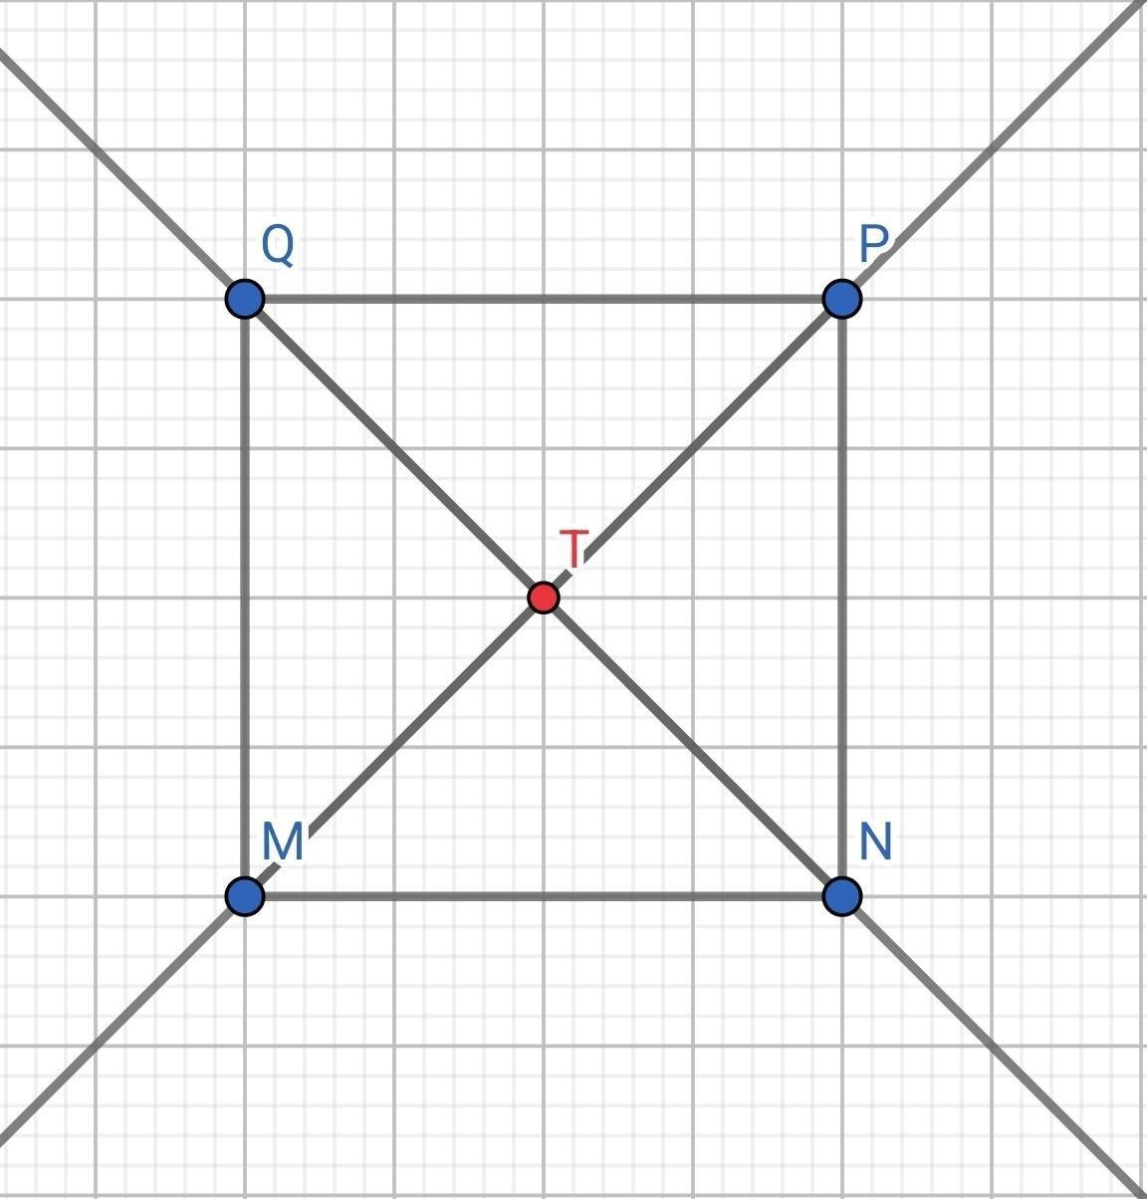
These intersections are useful for:
- Coordinate systems.
- Graphs.
- Maps.
- Technical drawings.
- Construction layouts.

Interior Intersection in CAD
# Source: AI Source: Provided by: [Data Path: Persons Table -> ID Column: 1, Name_En Column: Motasem Essam] -> From: [ChatGPT] on [7/25/2026]
CAD systems frequently identify interior intersections between:
- Line segments.
- Polygon edges.
- Arcs.
- Curves.
- Construction lines.
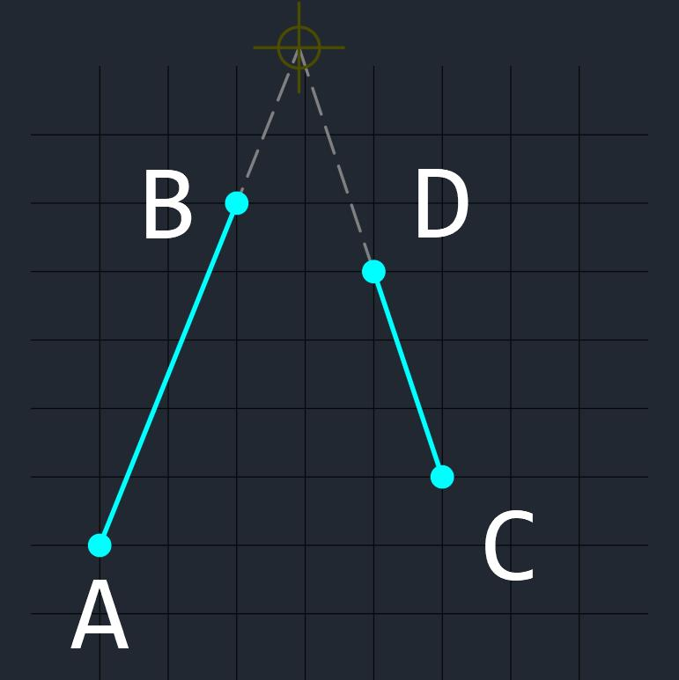
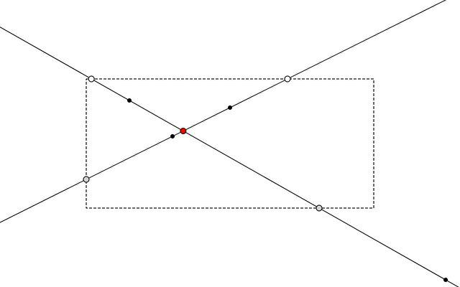
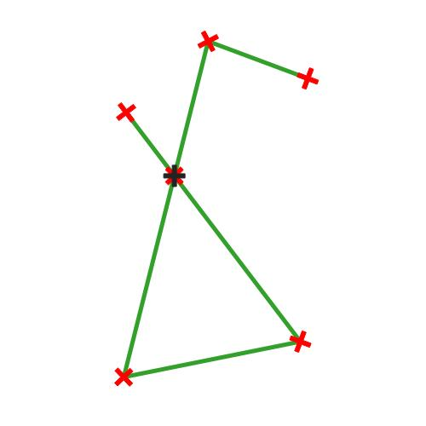
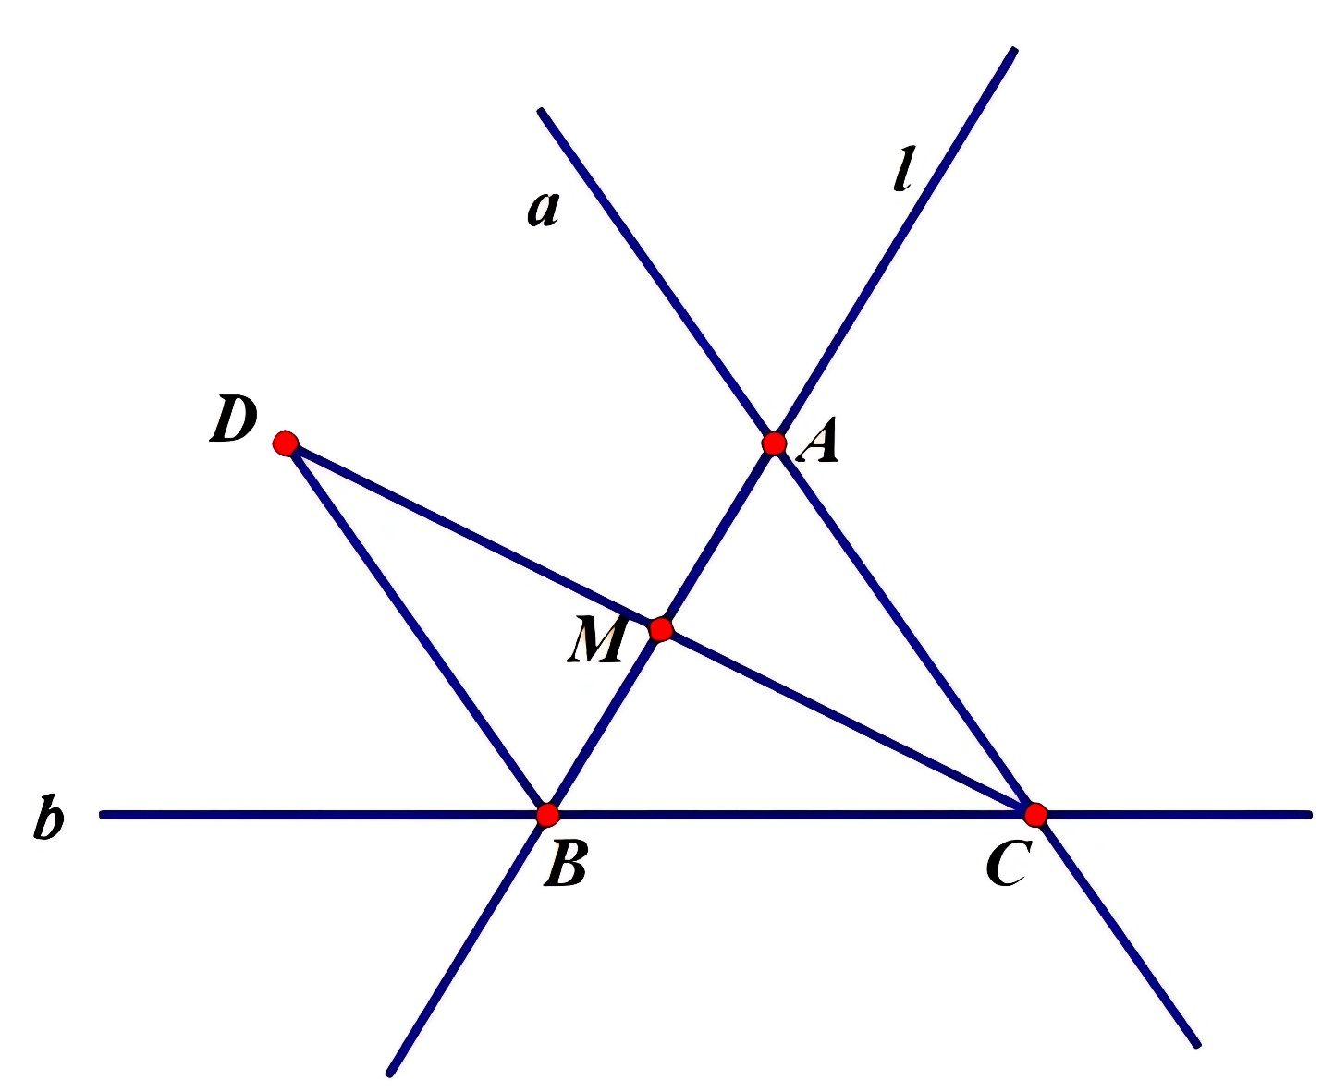
These intersection points can be used to:
- Trim objects.
- Split objects.
- Create vertices.
- Construct shapes.
- Define boundaries.

Interior Intersection in Engineering
# Source: AI Source: Provided by: [Data Path: Persons Table -> ID Column: 1, Name_En Column: Motasem Essam] -> From: [ChatGPT] on [7/25/2026]
Interior segment intersections occur in structural frameworks and technical designs.
For example, beams or structural members can cross at internal points.
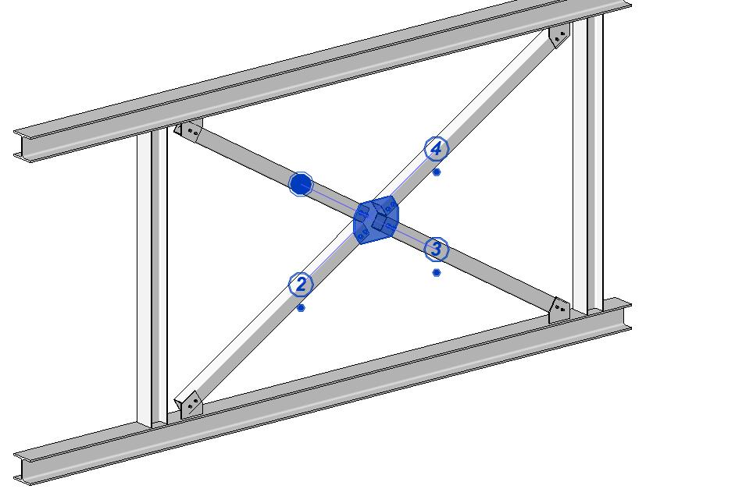
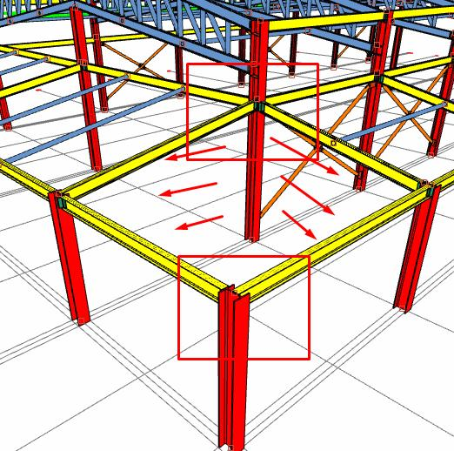
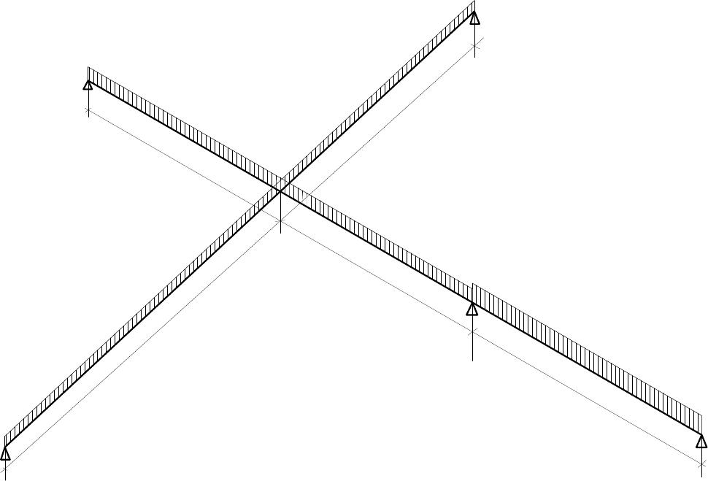
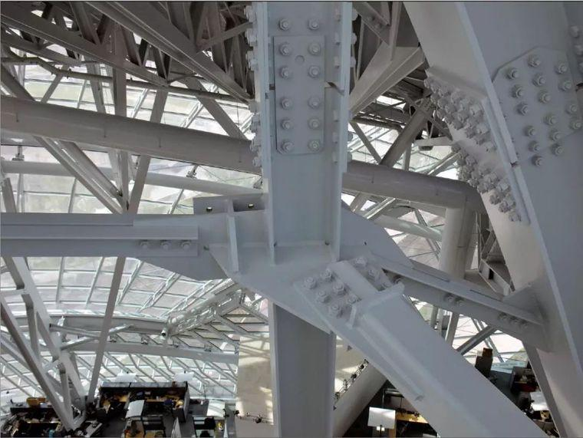
Such intersections can represent:
- Structural connections.
- Bracing.
- Frameworks.
- Mechanical components.

Interior Intersection in GIS
# Source: AI Source: Provided by: [Data Path: Persons Table -> ID Column: 1, Name_En Column: Motasem Essam] -> From: [ChatGPT] on [7/25/2026]
In GIS and mapping, line features can cross at interior points.
Examples include:
- Roads.
- Railway lines.
- Utility networks.
- Boundaries.
- Trails.
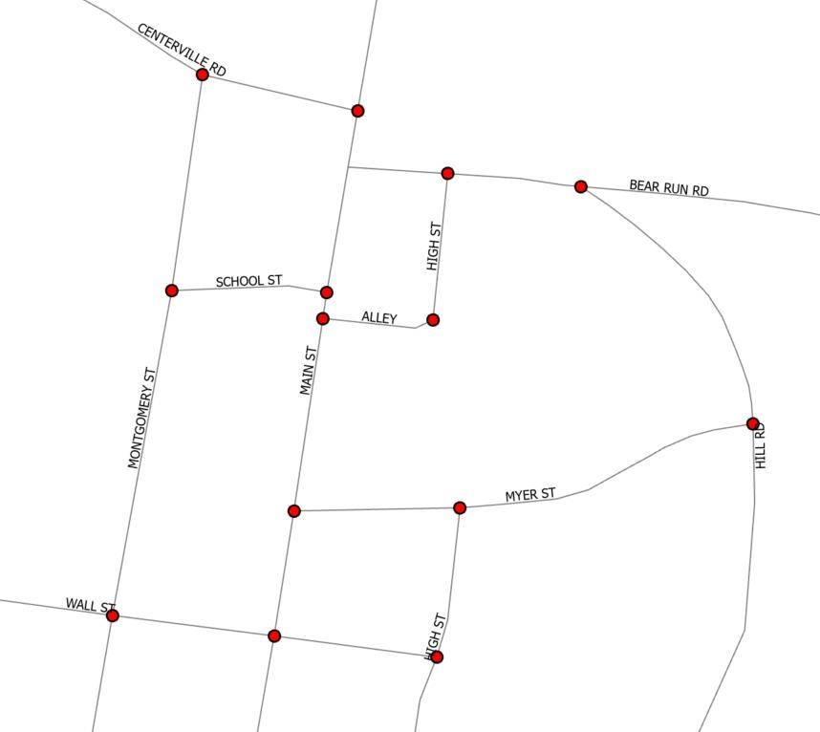
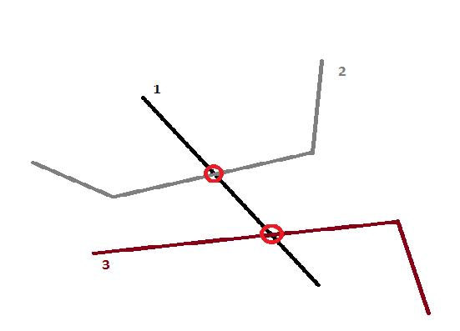
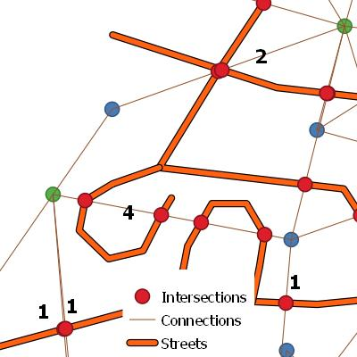
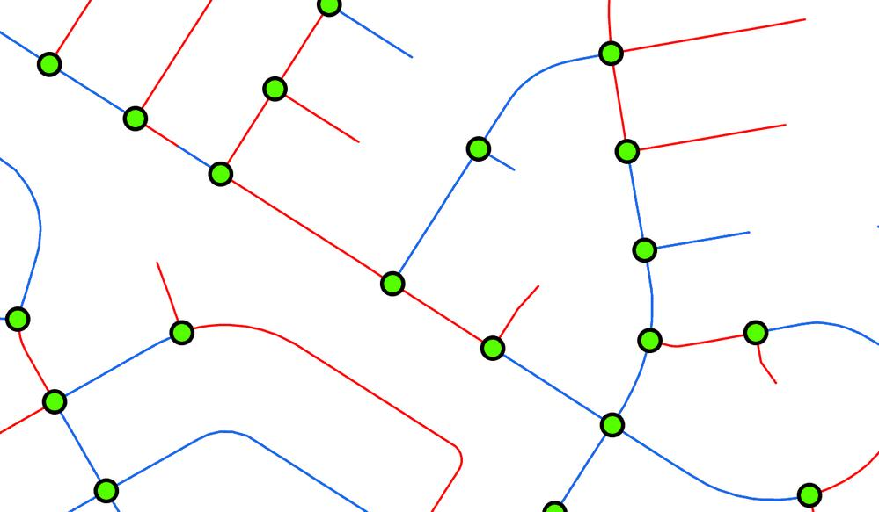
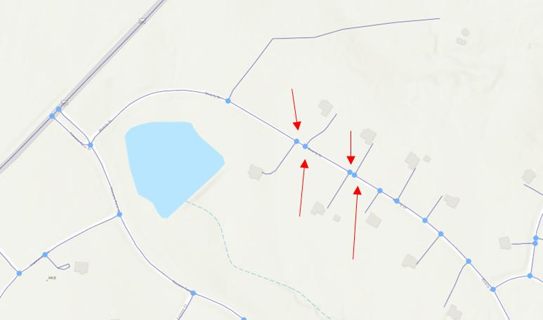
The intersection point can represent a junction or crossing.

Interior Intersection in Computer Graphics
# Source: AI Source: Provided by: [Data Path: Persons Table -> ID Column: 1, Name_En Column: Motasem Essam] -> From: [ChatGPT] on [7/25/2026]
Computer graphics uses interior segment intersections for:
- Collision detection.
- Polygon clipping.
- Shape construction.
- Vector graphics.
- 2D games.
- Geometric algorithms.
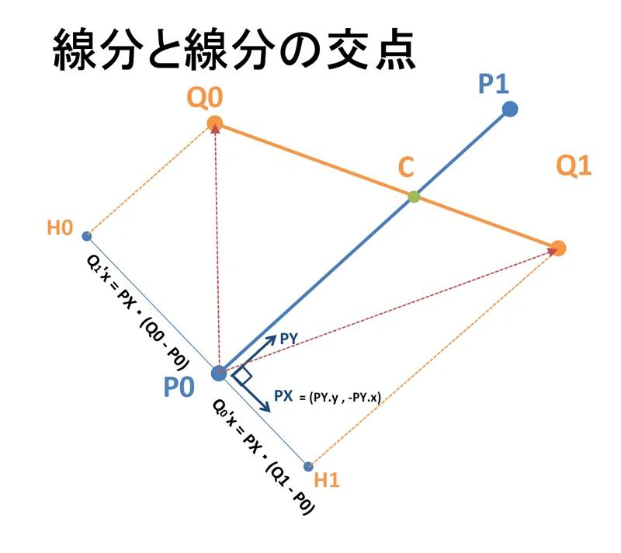
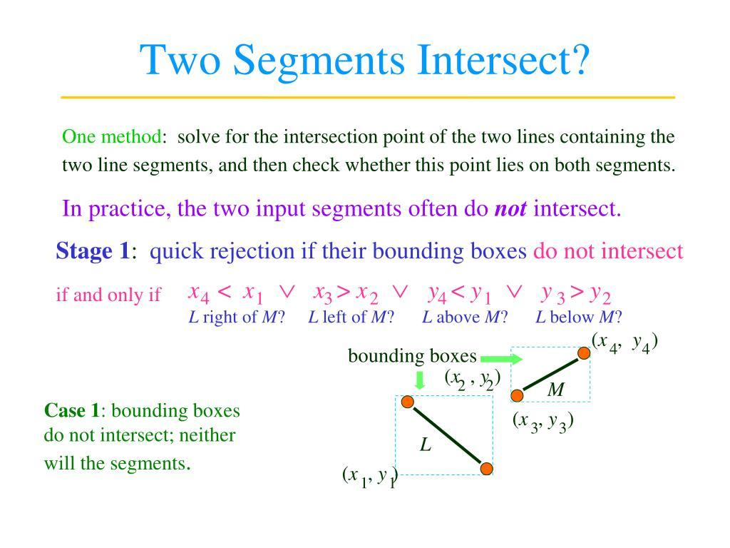
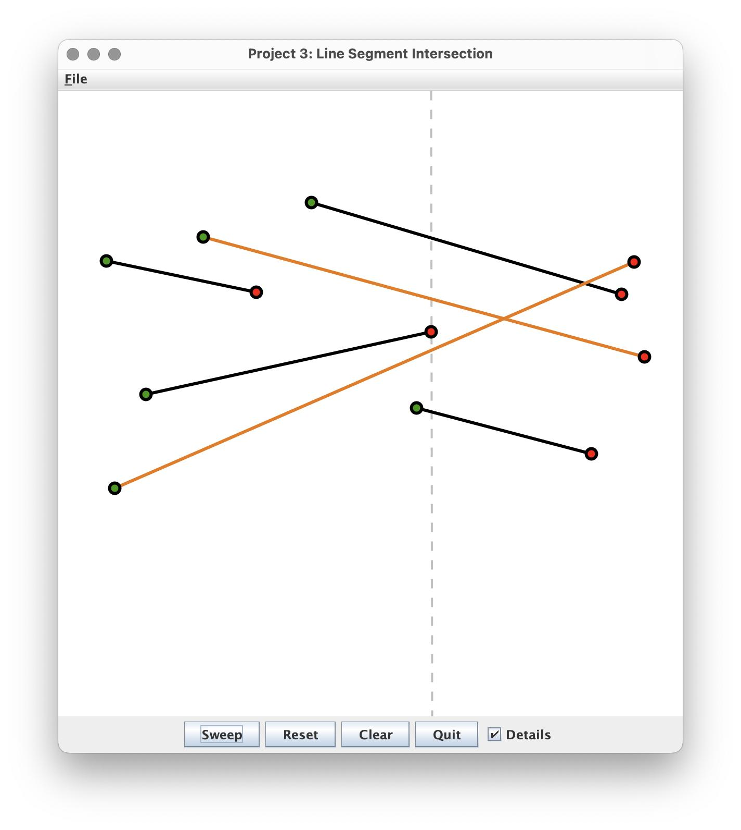
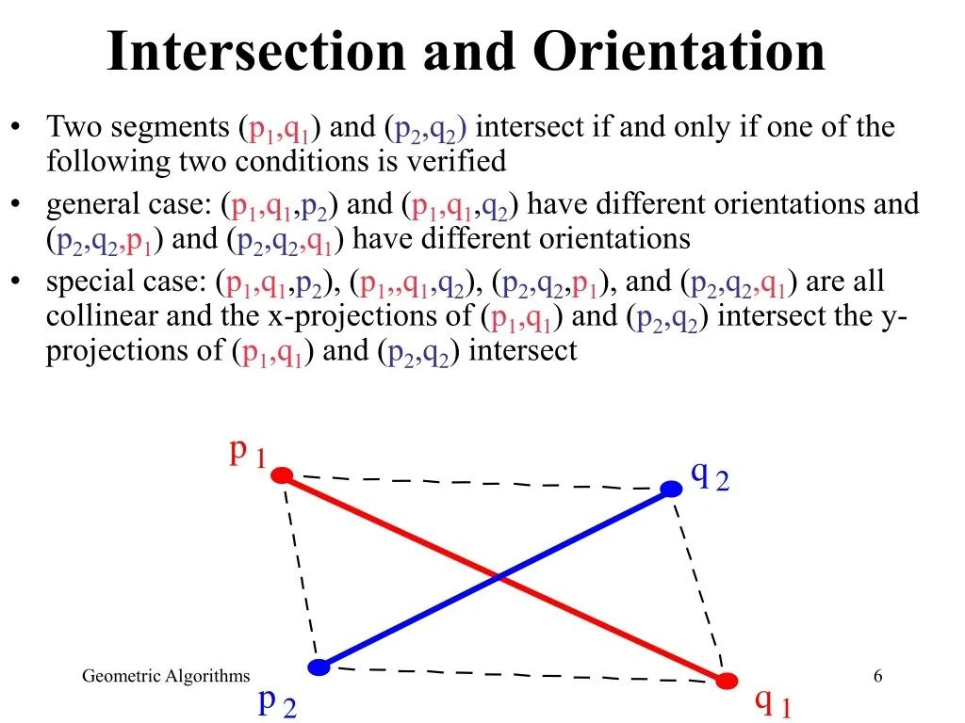
For example, a collision can be detected when two moving line segments cross at an interior point.

Real-World Examples
# Source: AI Source: Provided by: [Data Path: Persons Table -> ID Column: 1, Name_En Column: Motasem Essam] -> From: [ChatGPT] on [7/25/2026]
Interior intersections can represent:
- Two roads crossing away from their endpoints.
- Two beams crossing inside a framework.
- Two paths crossing.
- Two lines crossing inside a map region.
- Two diagonals crossing inside a polygon.
- Two sticks crossing at points away from their ends.
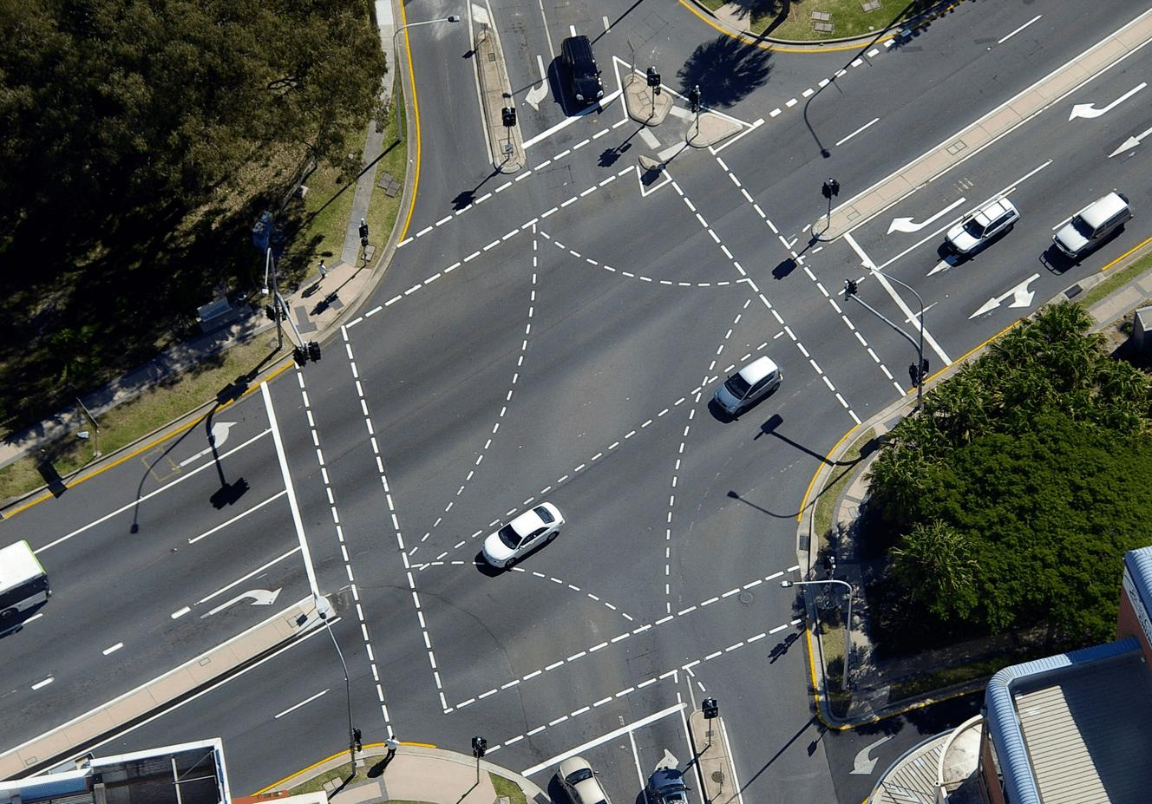
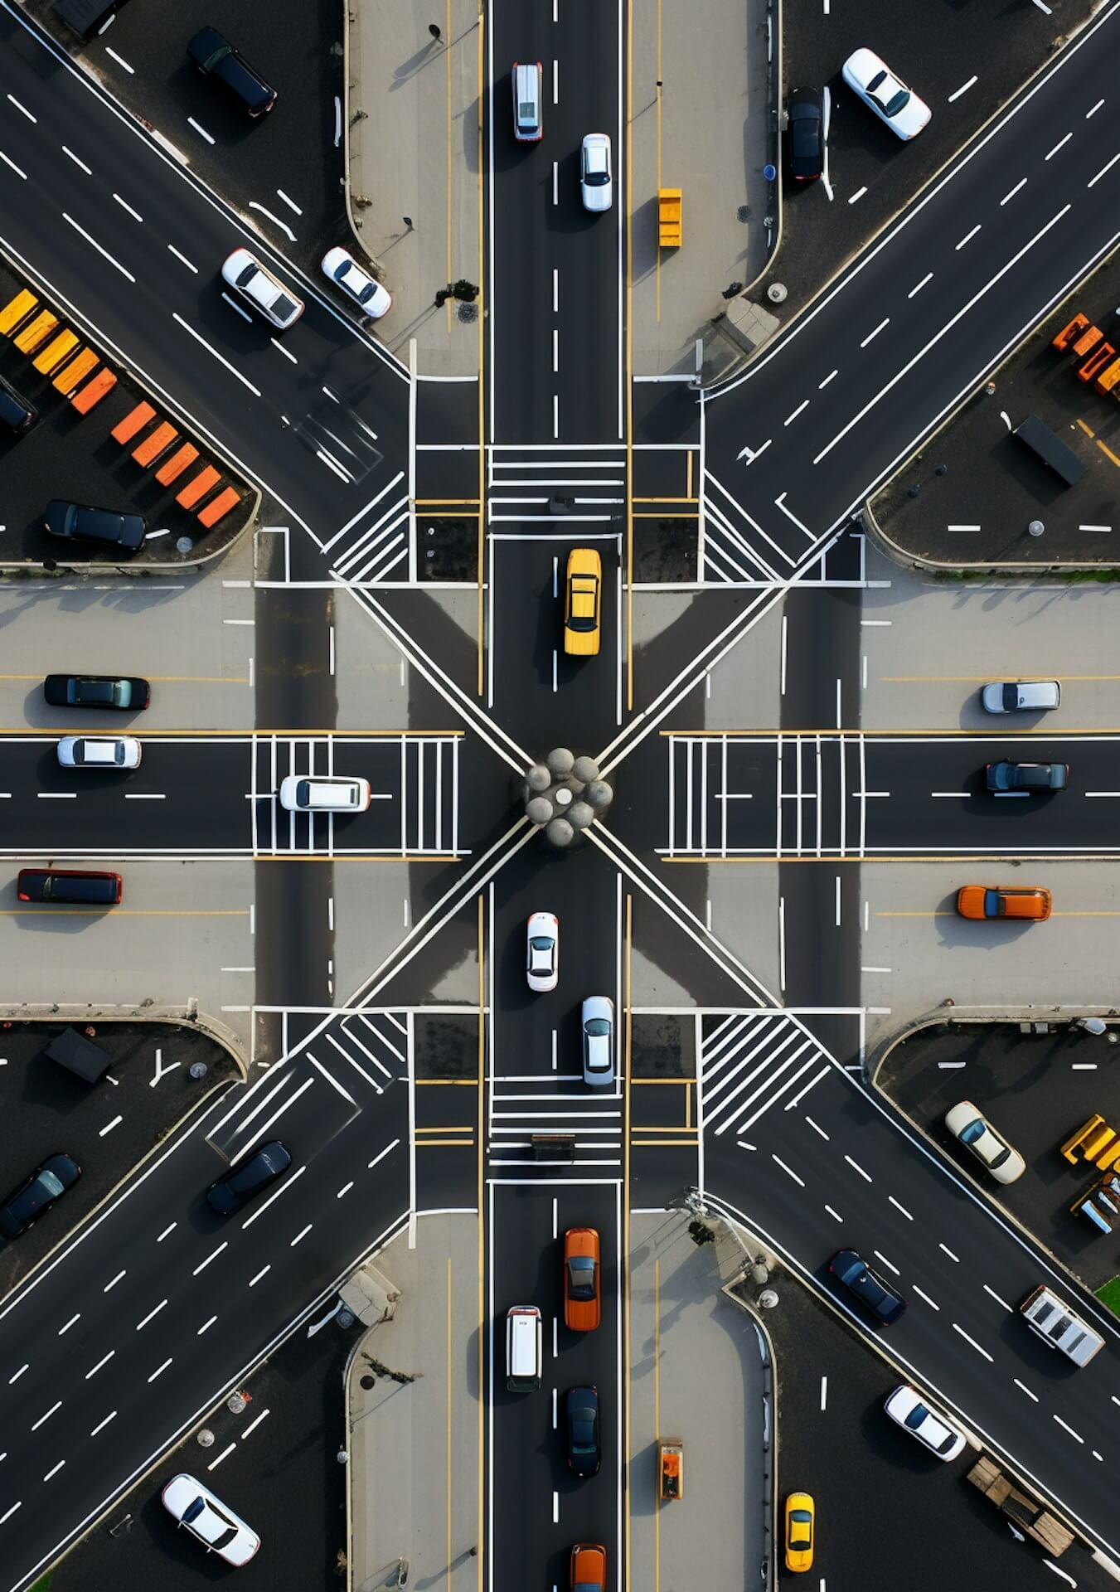
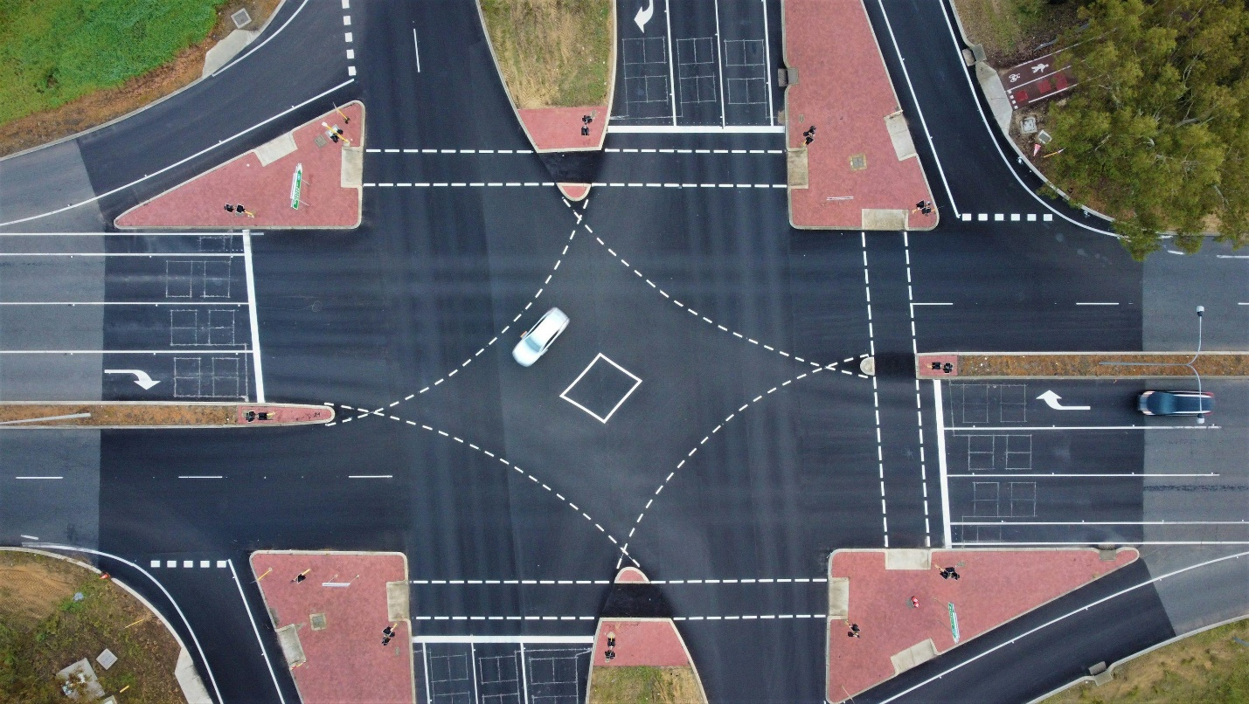
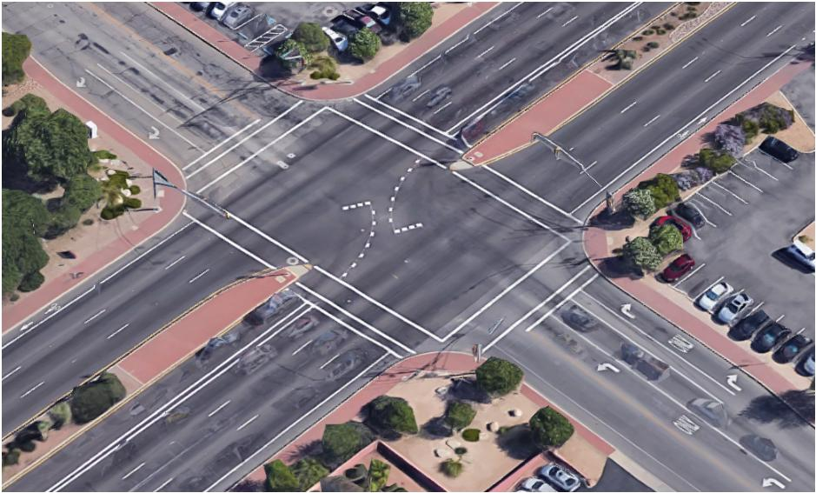


Applications
# Source: AI Source: Provided by: [Data Path: Persons Table -> ID Column: 1, Name_En Column: Motasem Essam] -> From: [ChatGPT] on [7/25/2026]
Interior intersection is important in:
- Plane Geometry
- Coordinate Geometry
- Euclidean Geometry
- Polygon Theory
- Computational Geometry
- Architecture
- Civil Engineering
- Mechanical Engineering
- Surveying
- GIS
- CAD
- Computer Graphics
- Robotics
- Navigation

Advantages
# Source: AI Source: Provided by: [Data Path: Persons Table -> ID Column: 1, Name_En Column: Motasem Essam] -> From: [ChatGPT] on [7/25/2026]
Studying interior intersections helps to:
- Identify crossing points accurately.
- Analyze polygon diagonals.
- Divide segments into smaller parts.
- Calculate intersection coordinates.
- Detect collisions.
- Analyze geometric structures.
- Construct complex figures.
- Understand angle relationships.
- Support engineering and CAD applications.

Limitations
# Source: AI Source: Provided by: [Data Path: Persons Table -> ID Column: 1, Name_En Column: Motasem Essam] -> From: [ChatGPT] on [7/25/2026]
Interior intersection:
- Requires the intersection point to lie strictly inside both segments.
- Does not include endpoint intersections.
- Does not describe segments that merely touch at an endpoint.
- Does not describe completely overlapping segments.
- Can require computational methods for complex coordinate systems.
- Can be difficult to determine visually when segments are very close together.

Comparison with Related Concepts
# Source: AI Source: Provided by: [Data Path: Persons Table -> ID Column: 1, Name_En Column: Motasem Essam] -> From: [ChatGPT] on [7/25/2026]
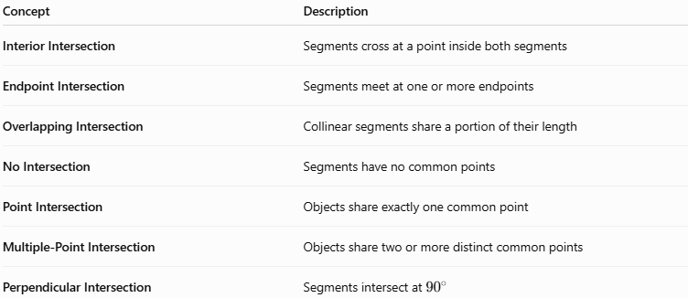
Concept | Description
Interior Intersection | Segments cross at a point inside both segments
Endpoint Intersection | Segments meet at one or more endpoints
Overlapping Intersection | Collinear segments share a portion of their length
No Intersection | Segments have no common points
Point Intersection | Objects share exactly one common point
Multiple-Point Intersection | Objects share two or more distinct common points
Perpendicular Intersection | Segments intersect at ${90}^{∘}$

Key Points
# Source: AI Source: Provided by: [Data Path: Persons Table -> ID Column: 1, Name_En Column: Motasem Essam] -> From: [ChatGPT] on [7/25/2026]
- Interior Intersection occurs when two line segments cross at a point that lies strictly inside both segments.
- If:
$$\boxed{\overline{AB}∩\overline{CD}=\{P\}}$$
and:
$$\boxed{P≠A,B,C,D}$$
then $P$ is an interior intersection point.
- In parametric form, an interior point satisfies:
$$\boxed{0<t<1}$$
- Interior intersections commonly occur between:
  - Polygon diagonals.
  - Crossing segments.
  - Construction lines.
  - Network paths.
- A perpendicular interior intersection forms four ${90}^{∘}$ angles.
- An interior intersection divides each segment into two smaller segments.
- Interior intersections are important in geometry, coordinate geometry, CAD, GIS, engineering, surveying, and computer graphics.

Conclusion
# Source: AI Source: Provided by: [Data Path: Persons Table -> ID Column: 1, Name_En Column: Motasem Essam] -> From: [ChatGPT] on [7/25/2026]
Interior Intersection is a specific type of Segment Intersection in which two line segments cross at a point located strictly inside both segments. The intersection point is not an endpoint of either segment and therefore satisfies conditions such as $0<t<1$ in a parametric representation. Interior intersections are commonly found in polygon diagonals, geometric constructions, coordinate geometry, structural designs, maps, CAD models, and computer graphics. They provide important information about crossing locations, segment division, angle relationships, and the structure of complex geometric figures.

